CFIHOS – Specification Document 规范

Version  版本 | Date  日期 | Comments/History  备注/记录
1.4 | April 2020  2020年4月 | IOGP republication of CFIHOS document first published in October 2019.  IOGP对首次于2019年10月发布的CFIHOS文档的再版。
1.4.1 | December 2020  2020年12月 | New sections added 增加新章：  2. ‘Purpose and Objectives’ (previously part of section 1. Scope) “2. 宗旨和目标”（之前属于“1. 范围”）  8. ‘Models’“8. 模型”
1.5 | October 2021  2021年10月 | Broadened PDF requirements to include scans or renderings in section 7.4.5. Updated Annex A.2 Figure 3 to include process, streams and classes and section 6.2 to reference all figures in Annex A.2.  扩大了PDF要求，在7.4.5 中包括扫描或渲染呈现形式。更新了A.2图3，包括工艺、流和类，6.2引用了A.2中所有的图。
1.5.1 | 2022-11  2022年11月 | Minor text changes for bug fixes throughout the text of the document. Added ISO 8601 reference  在本文件的整个文本中更正错误的次要文本变更。增加引用了ISO 8601。
2.0 | 2024-10-31  2024年10月31日 | Completely reformatted into requirements document to support use of requirements management tools完全重排格式为要求文档，以支持使用要求管理工具。

Acknowledgements致谢
In 2012, Shell approached Netherlands-based process industry organization USPI to explore turning their corporate information standard into an industry-wide standard. The result was the CFIHOS (Capital Facilities Information Handover Specification) project.
壳牌于2012年与总部位于荷兰的流程工业组织USPI（荷兰流程工业协会）接洽，希望将其企业信息标准转化为行业标准，因而形成了CFIHOS（资产密集型设施信息移交规范）项目。
Its aim is to offer practical, standardized specifications for information handover that work across the supply chain – operators, contractors and suppliers. The most recent CFIHOS industry standard (Version 1.4) was published in October 2019 by USPI with support from the Engineering Advancement Association of Japan (ENAA). This document, describing the scope and procedures of CFIHOS, is part of this specification.
CFIHOS项目旨在为信息移交提供实用标准化规范，该规范适用于整个供应链——运行方、承包方和供应方。CFIHOS 1.4版是由USPI在ENAA（日本工程协会）支持下发布的最新版，于2019年10月发布。本文件描述CFIHOS的规范，是该标准的一部分。
Following a member vote in 2019, the future governance, development, and maintenance of the CFIHOS project and standard moved from USPI to IOGP in January 2020, becoming Joint Industry Project (JIP)36.
2019年经成员投票表决，CFIHOS项目和标准的未来治理、编制和维护于2020年1月从USPI移至IOGP（国际油气生产方协会），成为JIP36（第36号联合工业项目）。

Disclaimer 免责声明
Whilst every effort has been made to ensure the accuracy of the information contained in this publication, neither IOGP nor any of its Members past present or future warrants its accuracy or will, regardless of its or their negligence, assume liability for any foreseeable or unforeseeable use made thereof, which liability is hereby excluded. Consequently, such use is at the recipient’s own risk on the basis that any use by the recipient constitutes agreement to the terms of this disclaimer. The recipient is obliged to inform any subsequent recipient of such terms.
尽管已尽一切努力确保本出版物中所含信息的准确性，但IOGP及其任何成员过去现在或未来均不保证其准确性，或无论其疏忽，均不对任何可预见或不可预见的使用承担责任，特此排除这些责任。受方的任何使用均构成对本免责声明条款的同意，因此此类使用的风险由受方自行承担。受方有义务将此类条款通知任何后续受方。
This publication is made available for information purposes and solely for the private use of the user. IOGP will not directly or indirectly endorse, approve or accredit the content of any course, event or otherwise where this publication will be reproduced.
本出版物仅供参考，仅供用户自用。IOGP不会直接或间接认可、批准或授权将复制本出版物的任何课程、活动或其他。

Copyright notice 版权声明
The contents of these pages are © International Association of Oil & Gas Producers.
Permission is given to reproduce this report in whole or in part provided (i)
that the copyright of IOGP and (ii) the sources are acknowledged. All other rights are
reserved. Any other use requires the prior written permission of IOGP.
各页内容版权由IOGP所有（© International Association of Oil & Gas Producers）。在 (i) IOGP的版权和 (ii) 来源得到承认的前提下允许全部或部分复制本报告。IOGP保留所有其他权利。任何其他用途都需要IOGP事先书面许可。
These Terms and Conditions shall be governed by and construed in accordance with the laws of England and Wales. Disputes arising here from shall be exclusively subject to the jurisdiction of the courts of England and Wales.
这些条款和条件应受英格兰和威尔士法律管辖并按其解释。由此产生的争议应仅受英格兰和威尔士法院的管辖。

Foreword 前言
The Capital Facilities Information Handover Specification (CFIHOS) is an industry standard developed to improve how technical information is exchanged between principals, contractors and suppliers/manufacturers for the process and energy sectors. Starting with a common engineering dictionary and supporting specifications, the CFIHOS goal is to become a common language for the exchange of technical information in these sectors.
CFIHOS（资产密集型设施信息移交规范）是一项为改进流程与能源行业委托方、承包方和供应方/制造方之间如何交换技术信息而制定的行业标准。CFIHOS始于公用工程字典和支持规范，目标是成为流程与能源行业信息交换的公用语言。
CFIHOS is being developed collaboratively by principal (owner/operator) companies, EPC Contractors, software providers and equipment vendors/suppliers/manufacturers as a practical standard to ensure the systematic and reliable exchange of information among all companies involved in the data supply chain, thereby reducing cycle times and costs.
CFIHOS由委托方（业主/运行方）公司、EPC承包方、软件提供方及设备供方（供应方/制造方）作为实用标准协作编制，以确保数据供应链中涉及的所有参与公司之间的系统及可靠的信息交换，从而缩短周期并降低成本。
The initial focus is on the information, as computer models, structured data and traditional document formats, are handed over when a project moves from its development to operations phase. Ultimately, the aim is for CFIHOS to become the de-facto standard for information exchange throughout the physical asset lifecycle, from vendor information through to decommissioning.
CFIHOS起初关注项目从开发阶段进入运行阶段时必须移交的信息，如计算机模型、结构化数据和传统文档格式信息。CFIHOS终极目标是成为从供方信息至退役的整个物理资产生命周期信息交换的事实标准。

Table of Contents 目次
Foreword 前言 5
1. Scope 范围 8
1.1. Inclusions 包含 8
1.2. Exclusions 不包含 9
1.3. Purpose 宗旨 9
2. Normative References 规范性引用文件 10
3. Terms, definitions and abbreviated terms 术语、定义和缩略语 11
3.1. Terms and definitions 术语、定义 11
3.2. Abbreviated terms 缩略语 16
4. Applicable Standards and Documents 适用标准和文档 18
4.1. Overview 概述 18
4.2. International Standards 国际标准 18
4.3. CFIHOS C-ST-001, CFIHOS Reference Data Library (RDL) CFIHOS RDL（参考数据类库） 19
5. Data 数据 21
5.1. Data Specification 数据规范 21
5.2. Application neutral data 应用程序中立数据 21
5.3. Application Specific Data 应用程序特定数据 23
5.4. Plant Breakdown Structure 工厂分解结构 23
5.5. Process, Streams and Cases 工艺、流和工况 25
5.6. Tag and Equipment Class Properties 位号和设备类特性 25
5.7. Data Specification 数据规范 27
6. Documents 文档 31
6.1. General 总则 31
6.2. Document Specification 文档规范 34
6.3. Document Numbering 文档编码 34
6.4. Discipline 专业 36
6.5. Document Type Classification 文档类型分类 36
6.6. Discipline Document Type Classification 专业文档类型分类 37
6.7. Document Metadata 文档元数据 39
6.8. Document Books (or binders) 文档卷册（或文档活页册） 40
6.9. File Requirements 文件要求 41
6.10. Additional Files 附加文件 43
6.11. Files to be delivered 要交付文件 44
6.12. Image Quality 图片质量 46
6.13. Hyperlinks 超链接 48
6.14. Different Languages 不同语言 48
6.15. Character Set 字符集 50
6.16. Document Size 文档尺寸 51
6.17. Document References 文档引用 51
6.18. Physical Record Requirements 物理记录要求 53
7. Application Specific Databases 应用程序特定数据库 54
7.1. Application Specific Databases 应用程序特定数据库 54
Annex A - Information Specification附录A 信息规范 62
A.1 General 总则 62
A.2 Data Model 数据模型 62
A.3 Data Dictionary 数据字典 69
A.4 Application Specific Data 应用程序特定数据 72
Bibliography 参考文献 75

List of Tables 表
Table A.1 - Data Dictionary Descriptions 表A.1 数据字典描述 70
Table A.2 - Application Specific Database Examples 表A.2 应用程序特定数据库示例 72
List of Figures 图
Figure A.1 - High-level overview of the complete model 图A.1 完整模型高阶概览 65
Figure A.2 - Overview of the Plant Breakdown Structure 图A.2 工厂分解结构概览 66
Figure A.3 - Overview of the Classifications and Properties including Processes, Streams and Cases 图A.3 分类和特性（包括工艺、流和工况）概览 67
Figure A.4 - Overview of the document management metadata 图A.4 文档管理元数据概览 68
Figure A.5 - Overview of metadata requirements at time of procurement 图A.5 采购时元数据要求概览 69

Introduction 引言
This document provides the requirements for engineering information handover specification for capital facilities between principals, contractors and suppliers/manufacturers. It specifies the engineering information principals require for future operation and maintenance of their facilities.
本文件提供资产密集型设施委托方、承包方和供应方/制造方之间工程信息移交规范的要求，规定委托方未来对其设施进行运维所需工程信息。
CFIHOS Implementation Guide for Principal [C-GD-001] and CFIHOS Implementation Guide for Contractor [C-GD-002] provide detailed guidance on how to use this specification.
CFIHOS委托方实施指南[C-GD-001]和CFIHOS承包方实施指南[C-GD-002]提供如何使用本文件的详细指导。
The CFIHOS unique ID can be found at the start of each requirement, CFIHOS-SPTR-0001.
每个要求起始均有CFIHOS唯一ID。

Scope 范围
CFIHOS-SPTR-1

Inclusions 包含
This specification covers the following:
- handover of information for production facilities;
- handover of information along the process industry plant engineering supply chain that consists of principals, contractors, and suppliers/manufacturers where the following applies:
  - The principal is the end client company that owns the production facility and is responsible for operation and maintenance.
  - The contractor is responsible for design, detailed engineering, procurement, construction and commissioning of a facility.
  - The maintenance contractor maintains and/or operates the facility.
  - The supplier/manufacturer delivers the equipment used to construct a facility and is responsible for the design, manufacturing and assembly of a particular piece of equipment.
- part of engineering information created by the contractor and the supplier/manufacturer required by the principal to operate and maintain a facility and to support future design changes.
本文件涵盖以下：
- 生产设施信息移交；
- 流程工业工厂工程供应链（由委托方、承包方和供应方/制造方组成）信息移交，其中：
  - 委托方是拥有并负责运维生产设施的最终客户公司；
  - 承包方负责设施的设计、详细工程设计、采购、施工和调试；
  - 维修承包方维护和/或运行设施；
  - 供应方/制造方交付用于建造设施的设备，并负责特定设备的设计、制造和组装。
- 由承包方和供应方/制造方创建，委托方设施运维及未来设计变更支持需要的那部分工程信息。
CFIHOS-SPTR-2

Exclusions 不包含
The scope of this specification excludes the following:
- engineering information created by the contractor and the supplier/manufacturer that is not required by the principal to operate and maintain a facility or to support any future design changes;
- processes that govern how the contractor or the supplier/manufacturer creates and/or quality assures the engineering information;
- systems used to develop the information nor the systems in which the information will be quality assured and stored at handover.
不在本文件范围内：
- 由承包方和供应方/制造方创建，委托方设施运维或任何未来设计变更不需要的工程信息；
- 承包方或供应方/制造方如何创建工程信息和/或保证其质量的管控流程；
- 用于生成信息的系统，或移交时保证信息质量和存储信息的系统。
CFIHOS-SPTR-3

Purpose 宗旨
The purpose of this document is to create a standard specification for principals, contractors and suppliers/manufacturers for the handover of engineering information in a facilities project, such that:
- this specification is an integral part of the full set of specifications which specifies the physical plant and information required.
- the information satisfies:
  - information requirements from statutory authorities;
  - approval and acceptance of delivery by the involved stakeholders;
  - design for future changes to the plant;
  - operation and maintenance during the lifetime of the plant;
- the specification can be applied across the supply chain.
本文件旨在为委托方、承包方和供应方/制造方创建标准的规范，以在设施项目中移交工程信息：
- 该规范是规定物理工厂和要求信息的整套规范的组成部分。
- 该信息满足：
  - 法定机构的信息要求
  - 涉及的利益相关方对交付的批准和验收
  - 工厂未来变更设计
  - 工厂生命周期运维
- 本文件能适用于整个供应链。

Normative References 规范性引用文件
The following documents are referred to in the text in such a way that some or all of their content constitutes requirements of this document. For dated references, only the edition cited applies. For undated references, the latest edition of the referenced document (including any amendments) applies.
以下文件在文中被引用，其部分或全部内容构成了本文件的要求。注日期的引用文件，仅该日期对应的版本适用于本文件，不注日期的引用文件，其最新版本（包括所有的修改单）适用于本文件。
CFIHOS-NR-1
CFIHOS C-DM-001, CFIHOS Data Model
CFIHOS数据模型
CFIHOS-NR-2
CFIHOS C-DM-002, CFIHOS Data Dictionary
CFIHOS数据字典
CFIHOS-NR-3
CFIHOS C-GD-001, CFIHOS Implementation Guide for Principal
CFIHOS委托方实施指南
CFIHOS-NR-4
CFIHOS C-GD-002, CFIHOS Implementation Guide for Contractor
CFIHOS承包方实施指南
CFIHOS-NR-5
CFIHOS C-ST-001, CFIHOS Reference Data Library (RDL)
CFIHOS RDL（参考数据类库）
CFIHOS-NR-6
CFIHOS C-TP-001, CFIHOS Scope and Procedure
CFIHOS范围与程序
CFIHOS-NR-7
ISO 8601-1, Date and time — Representations for information interchange — Part 1: Basic rules
日期和时间——信息交换表示法——第1部分：基本规则
CFIHOS-NR-8
ISO 216, Writing paper and certain classes of printed matter – trimmed size
印刷、书写和绘图纸幅面尺寸
CFIHOS-NR-9
ISO 5457, Technical product documentation, sizes and layout of drawing sheets
技术制图 图纸幅面和格式
CFIHOS-NR-10
ISO 3166-1, Codes for the representation of names of countries and their subdivisions
世界各国和地区名称代码
CFIHOS-NR-11
ISO/IEC 10646, Information technology – universal coded character set (UCS)
信息技术 通用多八位编码字符集（UCS）
CFIHOS-NR-12
ISO/IEC 8859-15, Information technology – 8-bit single-byte coded graphic character sets
信息处理 八位单字节编码图形字符集

Terms, definitions and abbreviated terms 术语、定义和缩略语

Terms and definitions 术语、定义
CFIHOS-DEF-1

additional files 附加文件
logical collection of physical computer files that are associated to one document revision identification
与一个文档版本标识相关联的物理计算机文件的逻辑收集。
CFIHOS-DEF-2

application 应用程序
computer program designed to help people perform an activity
为帮助人们进行某项活动而设计的计算机程序。
CFIHOS-DEF-3

application neutral data 应用程序中立数据
data that should be specified and exchanged using an industry standard that is independent of specific software (e.g. CFIHOS, DEXPI etc.)
宜使用独立于特定软件的行业标准（例如，CFIHOS、DEXPI等）进行规定和交换的数据。
CFIHOS-DEF-4

application specific data 应用程序特定数据
data that cannot be specified and exchanged using an industry standard, which instead necessitates data exchange based on proprietary software format
不能使用行业标准进行规定和交换而需要基于专有软件格式进行数据交换的数据。
CFIHOS-DEF-5

approved for construction 批准用于施工
formal milestone indicating the start of construction/erection activities. Information assigned this status should be used to support construction activities
指明施工/安装活动开始的正式里程碑。赋以此状态的信息宜用于支持施工活动。
CFIHOS-DEF-6

as-built 竣工状态
describing documentation, data and models associated with the facility, system or component that represents the actual physical “as is” situation
描述与设施、系统或部件相关联的文档、数据和模型，表示实际物理“现状”。
CFIHOS-DEF-7

as-design 设计状态
documentation, data and models associated with the facility, system or component that represents the initial design and subsequently incorporates all approved design changes
描述与设施、系统或部件相关联的文档、数据和模型，表示初始的设计及之后纳入所有批准了的设计变更。
CFIHOS-DEF-8

contract information management scope of work 合同信息管理工作范围
document in which the principal specifies the terms and conditions for information delivery by the contractor. Where it is applicable and feasible, quality benchmarks and criteria to fulfil them should be included
委托方规定承包方交付信息的条款和条件的文档，宜在适用且可行的情况下包括满足这些要求的质量基准和准则。
CFIHOS-DEF-9

contract RDL 合同RDL（合同参考数据类库）
document in which the principal specifies the requirements of the RDL specific for the scope of contract based on the CFIHOS RDL and should include deviations from or additions to the CFIHOS RDL [C-ST-001]
委托方基于CFIHOS RDL[C-ST-001]规定合同范围特定RDL要求的文档，宜包括对CFIHOS RDL的偏离或补充。
CFIHOS-DEF-10

contractor 承包方
party that carries out all or part of the design, engineering, procurement, construction, commissioning or management of a project or operation of a facility
全部或部分项目设计、工程设计、采购、施工、调试或管理或设施运行的执行方。
CFIHOS-DEF-11

controlled document 受控文档
digital or hardcopy entity which is required by a company, a standards organization, or a regulatory agency to be managed within a tightly controlled process that maintains the integrity of its content through revision control
公司、标准组织或监管机构要求在严格控制的流程中进行管理的数字或硬拷贝实体，其内容完整性通过版本控制保持。
CFIHOS-DEF-12

discipline document type 专业文档类型
association between disciplines and document class names. In the CFIHOS context, this is a unique identifier for types of documents and has been developed for situations where a document class is common to more than one discipline. For example, a process engineering flow scheme should only be produced by the process discipline, whereas a data sheet could be produced by many disciplines depending on the equipment where each discipline is responsible for part of the content
专业和文档类名之间的一种关联。专业文档类型在CFIHOS中是文档类型的唯一标识符，针对一个以上专业公用一个文档类的情况制定。例如，工艺流程图宜仅由工艺专业生成；而数据表取决于具体设备，可能由多个专业生成，每个专业负责部分内容。
CFIHOS-DEF-13

export control classification number (ECCN) ECCN（出口管制分类编码）
alphanumeric code that identifies the level of export control for articles, technology, and software (collectively, "Items") that are exported from member states of the Wassenaar Arrangement on Export Controls for Conventional Arms and Dual-Use Goods and Technologies, including the United States. The ECCN classification that applies to any specific item is determined by referring to a table such as that issued for the United States by the Bureau of Industry and Security and for Europe by Regulation 428/2009
一个字母数字代码，用于标识从《关于常规武器和两用物品及技术出口管制的瓦森纳安排》成员国（包括美国）出口的物品、技术和软件（统称为“物项”）的出口管制级别。适用于具体物项的ECCN分类通过引用一张表格确定，如对于美国由工业和安全局发布的表格，及对于欧洲的第428/2009条例表格。
CFIHOS-DEF-14

facility 设施
plant 工厂
land, buildings, machinery, apparatus, and fixtures employed in carrying on a trade or an industrial business
用于贸易或工业业务的土地、建筑物、机械、仪器和器具。
CFIHOS-DEF-15

handover of information 信息移交
formal process between the principal and the contractor for transfer of ownership and responsibility for the change management of information aligned with the official acceptance of a physical facility
委托方与承包方之间转移信息所有权和变更管理责任的正式过程，与物理设施正式验收对齐。
CFIHOS-DEF-16

handover plant breakdown structure 移交工厂分解结构
plant breakdown structure that structures the handover deliverables in relation to the physical assets
用于构建与物理资产相关的移交交付物的工厂分解结构。
CFIHOS-DEF-17

maintenance contractor 维修承包方
party that maintains the plant on behalf of the principal
代表委托方维护工厂的一方。
CFIHOS-DEF-18

master document register (MDR) MDR（主文档清册）
list of documents and drawings items the principal would like to trace e.g. have technical documentation and meta-data available, during the lifetime of an industrial plant
委托方在工厂生命周期内要跟踪（例如，有可用的文档和元数据）的文档和图纸项列表。
CFIHOS-DEF-19

master tag register (MTR) MTR（主位号清册）
list of tagged items the principal would like to trace e.g. have technical data and documentation available, during the lifetime of an industrial plant
委托方在工厂生命周期内要跟踪（例如，有可用的技术数据和文档）的位号项列表。
CFIHOS-DEF-20

original equipment manufacturer (OEM) OEM（原厂）
company that originally manufactured the equipment item and from which the equipment supplier purchased the equipment ultimately for the principal’s use
最初制造设备项的公司，设备供应方从其购买设备以供委托方最终使用。
CFIHOS-DEF-21

principal 委托方
party that initiates the project and ultimately pays for it, including any agent or consultant authorized to act for, and on behalf of, the principal
发起项目并最终为其出资的一方，包括任何被授权代表委托方并为其行事的代理方或顾问方。
CFIHOS-DEF-22

reference data library (RDL) RDL（参考数据类库）
standard and unified naming convention for equipment classification, its properties, disciplines, and documents, a set of information requirement specifications for documents and tagged items
设备分类、设备分类特性、专业和文档、文档和位号项的信息要求规范集的标准及统一命名规范。

CFIHOS-DEF-23
shall 应
used to indicate that a provision is mandatory.
用于指明一项规定是强制性的。
CFIHOS-DEF-24

should 宜
is used to indicate that a provision is not mandatory but recommended as good practice
用于指明一项规定不是强制性的，但推荐作为良好实践。
CFIHOS-DEF-25

supplier 供应方
manufacturer 制造方
party that manufactures or supplies equipment and services to perform the duties specified by the contractor. The supplier/manufacturer should be the contractor where the principal is the end consumer of the equipment/service
供应方/制造方：执行承包方规定的任务，制造或供应设备及服务的一方。如果委托方是设备/服务的最终使用方，则供应方/制造方应该是承包方。

Abbreviated terms 缩略语
CFIHOS-AAS-1

DEXPI
Data Exchange in the Process Industry
流程工业数据交换
CFIHOS-AAS-2

FL3DMS
Facility Lifecycle 3D Modeling Standard
设施生命周期3D建模标准
CFIHOS-AAS-3

OCR
optical character recognition
光学字符识别

Applicable Standards and Documents 适用标准和文档
CFIHOS-SPTR-4

Overview 概述
This section describes the applicable standards and practices relevant to this document in specifying what information is handed over to the principal.
本章描述与本文件相关的适用标准和实践，规定移交给委托方什么信息。
CFIHOS-SPTR-5

International Standards 国际标准

International standards relevant to this area of work include 4.2 a) through 4.2 i):
与此工作领域相关的国际标准包括4.2 a)至4.2 i)：
- ISO 10303 is also known as STEP or the “Standard for the Exchange of Product model data”. It is a standard for the computer-deciphered representation and exchange of industrial product data. The objective is to provide a mechanism capable of describing product data throughout the life cycle of a product, independent from a particular system.
- ISO 14224 provides a comprehensive basis for the collection of Reliability and Maintenance (RM) data in a standard format for equipment in all facilities and operations within the petroleum, natural gas and petrochemical industries during the operational life cycle of equipment.
- ISO 15926 specifies a conceptual data model for computer representation of technical information about process plants.
- ISO 8601-1 specifies a standard date format of YYYY-MM-DD.
- ISO 216 and ISO 5457 specifies the document and drawing standard sheet sizes.
- ISO 4217 specifies the structure for a three-letter alphabetic code and an equivalent three-digit numeric code for the representation of currencies. For those currencies having minor units, it also shows the decimal relationship between such units and the currency itself.
- ISO 3166-1 defines the internationally recognized codes of letters and/or numbers that we can use when we refer to countries and their subdivisions.
- ISO/IEC 10646 specifies the architecture of the UCS and defines terms for its use.
- ISO 8859-15 specifies a set of 191 coded graphic characters identified as Latin alphabet No. 9. This set of coded graphic characters is intended for use in data and text processing applications and also for information interchange.
- ISO 10303也称为STEP或“产品模型数据交换标准”，是工业产品数据的计算机解码表示与交换标准，旨在提供一种能够独立于特定系统来描述整个产品生命周期中的产品数据机制。
- ISO 14224为在设备生命周期内，以标准格式采集石油、天然气和石化行业所有设施和运行中设备的RM（可靠性和维修）数据提供全面基准。
- ISO 15926规定流程工厂技术信息的计算机表示的一个概念数据模型。
- ISO 8601-1规定YYYY-MM-DD标准日期格式。
- ISO 216和ISO 5457规定文档和图纸标准纸张大小。
- ISO 4217规定用于表示货币的三字母字母代码和等效三位数数字代码的结构。对于具有小数单位的货币，它还显示了这些单位与货币本身之间的十进制关系。
- ISO 3166-1定义我们在引用国家及其细分时可以使用的国际公认的字母和/或数字代码。
- ISO/IEC 10646规定UCS的架构并定义了其使用术语。
- ISO 8859-15规定一组191个编码图形字符，这些字符被标识为拉丁字母九。这组编码图形字符旨在用于数据和文本处理应用程序以及信息互换。

CFIHOS C-ST-001, CFIHOS Reference Data Library (RDL) CFIHOS RDL（参考数据类库）
CFIHOS-SPTR-6

The CFIHOS RDL provides a standard and unified naming convention for equipment classification, its properties, disciplines and documents. It is a set of information requirement specifications for documents and tagged items. The CFIHOS RDL contains the following:

list of classes for tag and equipment (what the equipment does and what it is);

list of properties (attributes, measures, characteristics etc.);

lists of requirements by class (data and applicable document references);

list of disciplines;

list of document types;

relationships between data entities;

CFIHOS unique ID codes;
CFIHOS RDL为设备分类、设备分类特性、专业和文档提供一个标准且统一的命名规范，是文档和位号的一组信息要求规范。CFIHOS RDL包含以下内容：

位号和设备的类列表（设备功能和设备定义）

特性列表（属性、计量、特征等）

按类的要求列表（数据和适用的文档引用）

专业列表

文档类型列表

数据实体间关系

CFIHOS唯一标识符编码
CFIHOS-SPTR-7

The contractor shall deliver the plant data and applicable document references in conformance with the contract RDL based on the CFIHOS RDL and other principal specific documents including, engineering, tagging specification and document numbering specification.
承包方应交付符合基于CFIHOS RDL [C-ST-001]的合同RDL和其他委托方特定文档（包括工程、标识规范和文档编码规范）的工厂数据和适用的文档引用。
CFIHOS-SPTR-8

If updates to the contract RDL or reference data requirements are required, either the contractor shall submit a change request to the principal for approval or the principal shall formally transmit a change notification to the contractor who has the right to review and require a change order as appropriate.
如果需要更新合同RDL或参考数据要求，承包方应向委托方提交变更请求以获得批准，或委托人应正式向承包方传送变更通知，承包方有权复核并酌情要求变更单。
CFIHOS-SPTR-9

When updates to the contract RDL or reference data requirements are made, the contractor shall replace any earlier revisions of the reference data and ensure future compliance with the new revision.
当更新合同RDL或参考数据要求时，承包方应替换任何之前的参考数据版本，并确保符合新版本。
CFIHOS-SPTR-10

By application of the contract RDL, the contractor is able to determine the principal’s information requirements. See the following example:
- if a tag is classified as a temperature transmitter, the CFIHOS RDL defines which entity attribute and class-specific properties for that temperature transmitter need to be delivered by the contractor. Except for the entity attributes common to all classes, the property requirements would be different if a different classification is used.
- if a document is classified as a piping and instrumentation diagram, the CFIHOS RDL identifies the final status of the document to be handed over (e.g., as-built), when a native file format is required (at handover, during project or not required) and a document’s representation type (e.g. structured data).
承包方能够应用合同RDL确定委托方信息要求，见以下示例：
- 如果某位号分类为温度变送器，CFIHOS RDL定义承包方需要交付该温度变送器的哪些属性和类特定特性。除了所有类公用的实体属性，如果使用不同的分类，则特性要求将有所不同；
- 如果某文档分类为管道及仪表流程图，CFIHOS RDL确定要移交的文档的最终状态（例如竣工）、何时要求源文件格式（移交时、项目期间或不要求）和文档表示类型（例如结构化数据）。

Data 数据
CFIHOS-SPTR-11

Data Specification 数据规范
Data can be specified in either application neutral data or application specific database.
能通过应用程序中立数据或应用程序特定数据库规定数据。
CFIHOS-SPTR-12

Application neutral data 应用程序中立数据
Deliverables are generated and submitted via file(s) such as CSV or XLSX and make reference to international standards such as CFIHOS and ISO 19008, where applicable. As it is an industry standard, this CFIHOS Specification Document focuses on requirements for application neutral data, which are set out in section 5.
交付物通过如CSV或XLSX文件生成并提交，并在适用的情况下引用国际标准，如CFIHOS和ISO 19008。作为一个行业标准，本文件关注对应用程序中立数据的要求，见本章。

CFIHOS-SPTR-13

The contractor shall hand over all application neutral data in accordance with the contract requirements.
承包方应按合同要求移交所有应用程序中立数据。
CFIHOS-SPTR-14

The contractor shall ensure that all application neutral data delivered is consistent with corresponding information.
承包方应确保所有交付的应用程序中立数据与对应信息一致。
CFIHOS-SPTR-15

Application Specific Data 应用程序特定数据
The principal should provide a specification or template to enable import/upload of the data into the principal’s application. Requirements for application specific templates are set out in Section 7. Examples of application specific data deliverables, such as for models, are set out in Annex A.4. These deliverables are submitted via native files of the applications used to develop them.
委托方宜提供一个规范或模板，以使能数据导入/上传至委托方应用程序。对应用程序特定模板的要求见第7章。应用程序特定数据（如模型）交付物通过用于生成这些交付物的应用程序的源文件提交。交付物示例见附录A.4。
CFIHOS-SPTR-16

The contractor shall hand over all application specific data in accordance with the contract requirements.
承包方应按合同要求移交所有应用程序特定数据。
CFIHOS-SPTR-17

The contractor shall ensure that all application specific data delivered is consistent with corresponding information.
承包方应确保所有交付的应用程序特定数据与对应信息一致。
CFIHOS-SPTR-18

Plant Breakdown Structure 工厂分解结构
The plant breakdown structure (PBS) defines the hierarchy of engineering data objects and the relationships between them. (Annex A.2.2. Figure A.2) defines the PBS recognized by the principal for data handover.
PBS（工厂分解结构）定义工程数据对象的层次结构及其之间的关系。委托方认可的用于数据移交的PBS的定义见A.2.2图A.2。

Process, Streams and Cases 工艺、流和工况
CFIHOS-SPTR-19

At the earlier phase of plant lifecycle, that is preceding the “functional design of the plant and the specification of the assets (asset requirements)” phase, process activities (e.g. pumping, heating, distilling) and streams (e.g. flow of material, flow of heat/energy) data are generated to represent the functional requirements describing what conditions are necessary to convert (chemical) substances step-by-step into final products.
在工厂生命周期的前期阶段，即“工厂的功能设计和资产规格（资产要求）”阶段之前，生成工艺活动（例如泵送、加热、蒸馏）和流（例如材料流、热量能量流）数据，以表示描述将（化学）物质逐步转化为最终产品所需条件的功能要求。
CFIHOS-SPTR-20

Processes and streams define the requirements for tags (e.g. ‘we need a tag to perform pumping’), tags define the specification for equipment (e.g. ‘we have to order a centrifugal pump with the following features to implement/fulfil this tag’). The scope of the information required for handover is not limited to the specifications for equipment, but also the requirements for tags.
工艺和流界定对位号的要求（例如“我们需要一个位号来执行泵送”），位号界定设备的规格（例如“我们必须订购有以下特征的离心泵来实施/实现这个位号”）。移交要求的信息范围不仅限于设备规格，还包括对位号的要求。
CFIHOS-SPTR-21

Streams and process activities also have cases which enables the principal to follow the thoughts of the contractor process engineer who uses cases to view the various what-if scenarios of the process streams.
流和工艺活动还有多个工况，以使能委托方跟随承包方工艺工程师的思路，使用工况查看工艺流各种假设场景。
CFIHOS-SPTR-22

The relationship between processes, streams and cases is presented in A.2.2, Figure A.3.
工艺、流和工况之间的关系见A.2.2图A.3。

Tag and Equipment Class Properties 位号和设备类特性
CFIHOS-SPTR-23

Information of a facility is concerned with the functional definition of the facility (its operating parameters), and how the facility then fulfils the functional requirements i.e. the physical definition of the facility.
设施信息涉及设施功能定义（其运行参数），以及设施如何满足功能要求，即设施物理定义。
CFIHOS-SPTR-24

The classification of the tag, equipment or model part engineering data object is used to define functional and physical data properties requirements.
位号、设备或型号部件工程数据对象分类用于定义功能和物理数据特性要求。
CFIHOS-SPTR-25

Tag (functional) data properties are the technical design requirements for a tagged item, for example the ‘maximum design pressure’ of a pump. In this example, the functional data is contained in the datasheet of equipment developed by the design engineer for a piece of equipment.
位号（功能的）数据特性是对位号项的技术设计要求，例如泵的“最大设计压力”,此例中设计工程师为一台设备制定的设备数据表包含功能数据。
CFIHOS-SPTR-26

Equipment (physical) data properties pertain to the characteristics of the device used to fulfil the design requirements, for example the type, weight, and dimensions of a pump. Physical data is normally delivered to the contractor by the supplier or original equipment manufacturer (OEM).
设备（物理的）数据特性与用于满足设计要求的装置特征有关，例如泵的类型、重量和尺寸。物理数据通常由供应方或OEM（原厂）交付给承包方。

Data Specification 数据规范
CFIHOS-SPTR-27

The full dataset handed over by the contractor to the principal is defined in the Contract RDL and should be made up of the following:

The required relationships between the ENS to equipment classes and sub-classes, including associated functional & physical attributes.

The required relationships between the DNS to document classes and sub-classes, including associated functional & physical attributes.

The required relationships between the ENS & DNS and general classes and sub-classes

The type of information required for turnover to the operate phase.

The status of information required for turnover to the operate phase e.g., approved for construction, as built etc.

The format the document and drawing should be turned over in at the end of the project, e.g., MS Word, MS Excel, AutoCAD, PDF etc.

The format of the information required for turnover to the operate phase e.g., “Data Load File” templates etc.
- PBS data entities (tag, equipment) and their attributes.
- Tag and equipment class properties.
- Process, streams, and cases.
承包方移交至委托方的完整数据集在合同RDL中定义，宜由以下组成：
- ENS（工程编码系统）与设备类和子类之间所需的关系，包括相关的功能和物理属性。
- DNS（文档编码系统）与文档类和子类之间所需的关系，包括相关的功能和物理属性。
- ENS和DNS与一般类和子类之间所需的关系。
- 移交至运行阶段所需信息的类型。
- 移交至运行阶段所需信息的状态，例如，批准施工、竣工等。
- 项目结束时应移交文档和图纸的格式，例如MS Word、MS Excel、AutoCAD、PDF等。
- 移交至运行阶段所需信息的格式，例如“数据加载文件”模板等。
- PBS数据实体（位号、设备）及其属性。
- 位号和设备类特性。
- 工艺、流和工况。
CFIHOS-SPTR-28

The contractor shall verify tag numbers on contractor, supplier and subcontractor documents and drawings conform to the principal’s tag numbering specification.
承包方应验证承包方、供应方和分包方文档和图纸上的位号编码是否符合委托方位号编码规范。
CFIHOS-SPTR-29

The contractor shall deliver tag data in conformance with the contract RDL.
承包方应交付符合合同RDL的位号数据。
CFIHOS-SPTR-30

The contractor shall deliver tag data to the principal in a structured electronic format.
承包方应以结构化的电子格式将位号数据交付给委托方。
CFIHOS-SPTR-31

The contractor shall submit intermediate and final handover tag data at the principal’s request.
承包方应按委托方要求提交中间和最终移交位号数据。
CFIHOS-SPTR-32

The contractor shall verify all tag numbers are separately identified in the master tag register.
承包方应验证所有位号在主位号清册中单独标识。
CFIHOS-SPTR-33

The contractor shall verify the format of engineering units of measure used for tag data are consistent with the contract RDL.
承包方应验证用于位号数据的工程计量单位格式与合同RDL一致。
CFIHOS-SPTR-34

The contractor shall verify tag data is consistent with the corresponding information that appears in the latest approved revisions of issued documents and drawings, including manuals and dossiers.
承包方应验证位号数据是否与发布的文档和图纸（包括手册和档案）的最新批准版本中对应信息一致。
CFIHOS-SPTR-35

The contractor shall be responsible for the quality (completeness, correctness, and consistency) of tag data delivered by the contractor, the contractor’s suppliers and subcontractors.
承包方应负责承包方、承包方的供应方和分包方交付的位号数据质量（完整性、正确性和一致性）。
CFIHOS-SPTR-36

The contractor shall maintain tag-to-tag relationships electronically in accordance with the contract RDL.
承包方应按合同RDL以电子方式维护位号至位号之间的关系。

CFIHOS-SPTR-37

The contractor shall maintain tag-to-document number cross-references in accordance with the contract RDL.
承包方应按符合合同RDL维护位号至文档编码的交叉引用。
CFIHOS-SPTR-38

The contractor shall verify document numbers that are cross-referenced to tags against the master document register (MDR).
承包方应依据MDR（主文档清册）对交叉引用位号的文档编码进行验证。
CFIHOS-SPTR-39

The contractor shall verify valid OEM, model, and serial number are delivered to the principal in conformance with the contract RDL.
承包方应按符合合同RDL验证向委托方交付的有效OEM、型号和序列号。
CFIHOS-SPTR-40

The contractor shall provide spare parts data in conformance with the principal’s spares requirements and collection process.
承包方应提供符合委托方备件要求及采集过程的备件数据。
CFIHOS-SPTR-41

The contractor shall hand over all technical data (application neutral data, including “as-built” tag and equipment data, and application specific data) in conformance with this specification and the contract RDL, for the entire scope (including the supplier/manufacturer tagged items).
承包方应按符合合同RDL移交整个工作范围内完整“竣工”位号数据（包括供应方/制造方位号）。
CFIHOS-SPTR-42

The contractor shall provide all dates formatted in accordance with ISO 8601 standard.
承包方应按ISO 8601标准格式提供所有日期。
CFIHOS-SPTR-43

To support these requirements, reference the following in Annex A.2:
- High level overview of the data model (Annex A.2 Figure A.1)
- Overview of the document management metadata (Annex A.2 Figure A.4)
- Overview of metadata requirements during of procurement (Annex A.2 Figure A.5).
参考A.2以下内容以支持这些要求：
- 数据模型高阶概览（A.2 图A.1）
- 文档管理元数据概览（A.2 图A.4）
- 采购时元数据要求概览（A.2 图A.5）

Documents 文档

General 总则
CFIHOS-SPTR-44

The specifications for document handover are as stated in this document and the accompanying contract RDL.
文档移交规范由随附合同RDL和本文件明示。
CFIHOS-SPTR-45

The contractor shall verify all requirements are applied to all documents created as part of its scope, including those originated by the subcontractors and the suppliers/manufacturers.
承包方应验证所有要求已被应用于其工作范围中创建的所有文档，包括由分包方和供应方/制造方发起的文档。
CFIHOS-SPTR-46

The contractor shall verify all documents are submitted to the principal in accordance with the process described in the CFIHOS Scope and Procedure [C-TP-001] or as may be further instructed by the principal.
承包方应验证所有文档是否按CFIHOS范围与程序[C-TP-001]所述流程或按委托方或许进一步指示的方式提交给委托方。
CFIHOS-SPTR-47

The contractor shall verify document numbers on the contractor, supplier and subcontractor documents and drawings conform to the principal’s document numbering specification and are identified in the MDR.
承包方应验证承包方、供应方和分包方文档和图纸上的文档编号是否符合委托人的文档编码规范，并在MDR中标识。
CFIHOS-SPTR-48

The contractor shall deliver document and drawing data in conformance with the contract RDL.
承包方应按照合同RDL交付文档和图纸数据。
CFIHOS-SPTR-49

The contractor shall deliver document and drawing data to the principal in a structured electronic format.
承包方应以结构化的电子格式向委托人交付文档和图纸数据。
CFIHOS-SPTR-50

The contractor shall submit intermediate and final handover document and drawing data at the principal’s request.
承包方应根据委托人的要求提交中间和最终移交文档和图纸数据。
CFIHOS-SPTR-51

The contractor shall maintain document-to-document number cross-references in accordance with the contract RDL.
承包方应根据合同RDL维护文档至文档编码的交叉引用。
CFIHOS-SPTR-52

The contractor shall verify that documents are complete with annexes and attachments.
承包方应验证文档包含附录和附件是否完整。

CFIHOS-SPTR-53

The contractor shall verify that document cross references within documents and drawings are current, correct, and consistent.
承包方应验证文档和图纸中的文档交叉引用是当前的、正确的和一致的。

Document Specification 文档规范
CFIHOS-SPTR-54

The contractor shall deliver all documents to the principal in conformance with the contract RDL which provides a specification for the principal’s requirements in line with each document’s discipline and document type.
承包方应按符合合同RDL向委托方交付所有文档。合同RDL提供对应每份文档的专业和文档类型的委托方要求规范。
CFIHOS-SPTR-55

The contractor shall handle all deliverables as controlled documents.
承包方应将所有交付物作为受控文档处理。

Document Numbering 文档编码
CFIHOS-SPTR-56

The contractor shall verify all documents issued by the contractor, the subcontractors and the suppliers/manufacturers are numbered in conformance with the principal’s document numbering specification and are identified in the MDR.
承包方应验证承包方、分包方和供应方/制造方发布的所有文件编码均符合委托方文档编码规范并在MDR中标识。
CFIHOS-SPTR-57

The contractor shall use the document and drawing number consistently in the document content (electronic and hardcopy) and the document metadata provided to the principal.
承包方应在提供给委托方的文档内容（电子和硬拷贝）及文档元数据中始终一致使用此文档和图纸编码。
Note: The principal’s document numbering specification should account for documentation (such as off the shelf equipment) that may not benefit from re-numbering by the contractor.
注：委托方文档编码规范宜说明或许不适合承包方重新编码的文档（例如现货设备）。

CFIHOS-SPTR-58

The contractor shall produce a new revision whenever an update of a document is issued to the principal.
承包方应在向委托方发布文档更新时生成新版。
CFIHOS-SPTR-59

Revision coding shall be in conformance with the principal’s document numbering specification.
版本号应符合委托方文档编码规范。
CFIHOS-SPTR-60

Reason for issue shall be in conformance with principal’s document numbering specification.
发布理由应符合委托方文档编码规定。

Discipline 专业
CFIHOS-SPTR-61

The contractor shall assign a single discipline to documents in conformance with the contract RDL.
承包方应按符合合同RDL为文档赋以单一专业。
CFIHOS-SPTR-62

Discipline refers to a branch of knowledge of expertise which is responsible for the content of a deliverable.
专业指负责交付物内容的专门知识分支。
CFIHOS-SPTR-63

Document Type Classification 文档类型分类

The contractor shall assign a single document type to classify documents in conformance with the contract RDL.
承包方应按符合合同RDL以单一文档类型分类文档。
Note: The contract RDL may restrict specific document types to specific disciplines.
注：合同RDL可限制特定文档类型至特定专业。

Discipline Document Type Classification 专业文档类型分类
CFIHOS-SPTR-64

The combination of discipline and document type is an identification of the type of document required for each discipline, and its related delivery requirements in conformance with the contract RDL.
专业和文档类型的组合是对每个专业要求的文档类型的标识，其相关交付要求符合合同RDL。
CFIHOS-SPTR-65

The contractor shall verify all documents handed over to the principal satisfy the requirements of the discipline and document type combination in the contract RDL.
承包方应验证所有移交给委托方的文档满足合同RDL中专业和文档类型组合要求。
Note: If the contract RDL does not specify specific document type and discipline combinations the response from the contractor should be significant in the number of combinations.
注：如果合同RDL未规定特定文档类型与专业组合，承包方的响应在组合数量上应该有显著差异。
CFIHOS-SPTR-66

The contractor shall verify all documents handed over to the principal are assigned an appropriate discipline document type code and that all handover requirements of the relevant discipline document type code are satisfied in conformance with the contract RDL.
承包方应验证所有移交给委托方的文档已赋以适当的专业文档类型编码，且相关专业文档类型编码的所有移交要求均符合合同RDL。
Note: A set of documents should be formed into a book, as described in section 6.8 (if required) where similar documents of different discipline and document type combination need to be related or combined.
注：如6.8（如需）所述，如果需要关联或组合不同专业和文档类型组合的类似文档，宜将其成册。
CFIHOS-SPTR-67

The contractor shall not create new discipline and document type combinations without prior approval from the principal.
未经委托方事先批准，承包方不应创建新的专业和文档类型组合。
CFIHOS-SPTR-68

Document Metadata 文档元数据

The contractor shall verify each document revision submitted by the contractor to the principal shall be delivered along with the document metadata specified in the contract data dictionary.
承包方应验证向委托方提交的每个文档版本应与合同数据字典规定的元数据一起交付。

Document Books (or binders) 文档卷册（或文档活页册）
CFIHOS-SPTR-69

A book, i.e. a logical collection of documents and drawings, may be used to retain a natural grouping of documents (e.g., to record the documents delivered in a vendor package, regardless of their discipline document type).
卷册即文档和图纸的逻辑收集，可用于保留文档的自然分组（例如，不分专业文档类型记录供方供货包中交付的文档）。
CFIHOS-SPTR-70

The contractor shall create a separate document that contains the index of the book and classify it as a document type appropriate for the book.
承包方应创建一份包含卷册索引的单独文档，并将其分类为适合该卷册的文档类型。
CFIHOS-SPTR-71

The contractor shall assign a unique document number to each document in a book.
承包方应为卷册中的每份文档赋以一个唯一文档编码。
CFIHOS-SPTR-72

The contractor shall create a document-to-document reference between the index document and the documents in the book.
承包方应在索引文档和卷册中的文档之间建立文档至文档的引用。

File Requirements 文件要求
CFIHOS-SPTR-73

The contractor shall verify each document corresponds to at least one electronic file.
承包方应验证每份文档至少对应一份电子文件。
CFIHOS-SPTR-74

The contractor shall deliver each document rendition in a single electronic file.
承包方应以单一电子文件形式交付每份文档呈现副本。
CFIHOS-SPTR-75

The contractor shall create separate document numbers for each sheet of drawings with multiple sheets (for example piping and instrumentation diagrams) and submit each sheet/document number as a single electronic file.
承包方应为有多页的图纸（例如管道及仪表流程图）的每页创建单独的文档编码，并按每页/文档编码提交单一电子文件。
CFIHOS-SPTR-76

Each electronic file shall be self-contained and not require any other electronic files for viewing or updating purposes (e.g., X-Ref, shape files, non-true-type fonts, templates).
每个电子文件都应是自足的，其查看或更新无需任何其他电子文件（例如，X-Ref、形文件、非TTF字体（非全真字体）和模板）。
CFIHOS-SPTR-77

The maximum file size for a document shall be specified by the principal. Larger files should be allowed for files that are accessed rarely or for 3D Models that need to be handled as single document objects.
应由委托方规定文档的最大文件大小。对于很少访问的文件或需要作为单个文档对象处理的3D模型，宜容许使用更大的文件。
CFIHOS-SPTR-78

Files larger than the specified maximum size as stipulated by the principal in the contract shall be split into smaller files:
- at natural section breaks indicated by section markers;
- at the file size limit if the document has no natural section breaks but exceeds the allowable file size.
应将超过合同中委托方规定的最大大小的文件拆分成较小的文件：
- 在由分节符指明的自然的分节处；
- 如果文档没有自然的分节但超过容许的文件大小，则以文件上限。
Note: It is recommended that the principal specify a maximum file size in the contract and if appropriate also indicate an appropriate process for allowing larger files that are accessed rarely or for 3D models that need to be handled as single document objects.
注：建议委托方在合同中规定最大文件大小，并在适合的情况下，也指明一个适当的流程，对于很少访问的文件或需要作为单个文档对象处理的3D模型，容许使用更大的文件。
CFIHOS-SPTR-79

The contractor shall verify that image formats within a document are legible when embedded in an A4 document.
承包方应验证嵌入A4文档中的图像格式易于辨识。
CFIHOS-SPTR-80

The contractor shall accurately and completely represent the information on electronic files on equivalent paper deliverables.
承包方应在电子文件上准确并完整地表示等效纸质交付物信息。
CFIHOS-SPTR-81

Native files specified as the authenticated record format in the RDL shall contain the sign off signatures for the current issue.
在RDL中被规定为经认证的记录格式的源文件应包含当前发布版的签发签名。
CFIHOS-SPTR-82

The contractor shall verify that all file naming is in conformance with the principal’s document numbering specification.
承包方应验证文件命名符合委托方文档编码规范。
CFIHOS-SPTR-83

The contractor shall verify that file naming only contains alphabetic, numeric, and underscore characters (no special characters are allowed, and underscore should replace any slashes (/ or \))
承包方应验证文件名只包含字母、数字和下划线字符（不容许使用特殊字符），宜用下划线替换任何斜杠（/或\）。
CFIHOS-SPTR-84

The contractor shall verify that the file name does not imply any relevance (it shall be possible to rename the file without affecting the viewing or editing of that file or any other file).
承包方应验证文件名不隐含任何相关性，文件应能在不影响该文件或任何其他文件的查看或编辑的情况下重命名。

Additional Files 附加文件
CFIHOS-SPTR-85

The contractor shall use additional files indication in the transmittal when multiple files are delivered against a single document number revision. Examples include:

A document delivered in multiple renditions (e.g., a scanned PDF of the signed off document and a word processor native file of the same).

A document with an unacceptably large file size that has been divided into multiple files of acceptable size.

A single document containing multiple file types (e.g., a specification document with an attached data sheet).

A single document containing equivalent information in multiple languages.
以单一文档编码版本交付多个文件时，承包方应在传送单中使用附加文件指示。示例包括：
- 以多种呈现形式交付的文档（例如，已签发文档的扫描PDF和该文档的文字处理器源文件）；
- 超出文件大小限制已被分成多个可接受大小文件的文档；
- 包含多种文件类型的单一文档（例如，附数据表的规格书）；
- 包含多语言等效信息的单一文档。
CFIHOS-SPTR-86

When additional files are indicated, the contractor shall nominate the primary document and treat it in the same way as any other document, giving it a document number and revision code.
在指明附加文件的情况下，承包方应指定主文档，并以与其他任何文档相同的方式处理，给以文档编码和版本号。
CFIHOS-SPTR-87

When additional files are indicated, the contractor shall assign the same document number and revision code to all other (secondary) files in the set such that each document title and the file name reflects the sequence of the files as they appear in the complete document.
在指明附加文件的情况下，承包方应为该文件集所有其他（次要）文件赋以相同的文档编码和版本号，以使每个文档标题和文件名反映文件在完整文档中出现的顺序。
CFIHOS-SPTR-88

When additional files are indicated, the contractor shall verify the primary file contains the front sheet and table of contents.
在指明附加文件的情况下，承包方应验证主文件包含首页和目录。

Files to be delivered 要交付文件
CFIHOS-SPTR-89

The contractor shall deliver all documentation (final and intermediate revisions) electronically.
承包方应以电子方式交付所有文档（最终和中间版本）。
CFIHOS-SPTR-90

The contractor shall deliver a signed PDF rendition of all documents and drawings that are optical character recognition (OCR) enabled and fully text searchable along with the native files or other authenticated record format as specified by the principal.
承包方应与源文件一起交付所有文档和图纸的签名使能了OCR（光学字符识别）和文本搜索的PDF或委托方另行规定认证记录格式，PDF并文本搜索。

CFIHOS-SPTR-91

The contractor shall scan the document or drawing and deliver a PDF file that is OCR enabled and fully text searchable where the native format is paper.
如果源格式为纸质，承包方应扫描文档并交付使能了OCR（光学字符识别）和文本搜索的PDF文件。
CFIHOS-SPTR-92

The principal and the contractor shall determine which categories of documents require long time archiving.
委托方和承包方应确定要求长期存档的文档种类。
CFIHOS-SPTR-93

The contractor shall use the PDF/A format specified in ISO 19005-2 where files require long time archiving.
承包方应使用ISO19005-2规定的PDF/A格式储存要求长期存档的文件。
CFIHOS-SPTR-94

The contractor shall deliver the non-electronic native format when the principal and the contractor agree the native format cannot reasonably be converted to electronic media (for example radiographic films). See section 6.18 for the physical record handover requirements.
如果委托方和承包方同意源格式不能适当地转换为电子介质（例如射线胶片），承包方应交付非电子源格式。物理记录移交要求见6.18。
CFIHOS-SPTR-95

The contractor shall ensure that all files are fully virus checked before submission to the principal.
承包方应确保所有文件在提交给委托方前经过彻底的查毒。

Image Quality 图片质量
CFIHOS-SPTR-96

The contractor shall verify PDF files are rendered directly from the authoring application as content searchable PDF format with commenting enabled.
承包方应验证PDF文件为直接从文档创建应用程序生成的，可搜索内容并启用批注的PDF格式。

CFIHOS-SPTR-97

The contractor shall verify documents requiring a wet signature and/or official stamp(s) are PDF files scanned directly from the hardcopy documents.
承包方应验证要求手写签名和/或官方印章的文档为直接扫描自硬拷贝文档的PDF文件。
CFIHOS-SPTR-98

The contractor shall verify for all PDF files are rendered or scanned at their original size directly from the original hard copy.
承包方应验证所有PDF文件直接从原始硬拷贝中以原始尺寸生成或扫描。
CFIHOS-SPTR-99

The contractor shall verify for all PDF files images are rendered or scanned in an orientation that allows viewing without rotation.
承包方应验证所有PDF文件图像用无需旋转查看的方向呈现或扫描。
CFIHOS-SPTR-100

The contractor shall verify for all PDF files all rendered or scanned image files are split into smaller files if any are too large (refer to section 6.9 for more detail).
承包方应验证所有PDF文件如果生成或扫描的图像文件太大，则将其拆分为较小的文件（更详细信息见6.9）。
CFIHOS-SPTR-101

The contractor shall verify for all PDF files all information in a rendered or scanned document is legible and fully text searchable.
承包方应验证所有PDF文件生成或扫描文件中的所有信息都清楚易辨，并且可以全文搜索。
CFIHOS-SPTR-102

The contractor shall verify for all PDF files are rendered or scanned in colour at a resolution of at least 300 dpi.
承包方应验证所有PDF文件以至少300dpi分辨率彩色生成或扫描。
CFIHOS-SPTR-103

The contractor shall compare scanned images against an image quality benchmark agreed with the principal to determine if the image quality is sufficient.
承包方应依据一个与委托方商定的图像质量基准对比扫描图像，以确定图像是否质量达标。

Hyperlinks 超链接
CFIHOS-SPTR-104

The contractor/supplier shall not use hyperlinks to contractor’s intranet or shared drives.
承包方/供应方不应使用指向承包方内部网或共享盘的超链接。
CFIHOS-SPTR-105

The contractor/supplier shall not use hyperlinks between documents, but instead apply document to document relationships.
承包方/供应方不应在文档之间使用超链接，而应使用文档至文档关系。

Different Languages 不同语言
CFIHOS-SPTR-106

The principal shall define which language is regarded as the “master” language.
委托方应定义哪种语言被视为“主”语言。
CFIHOS-SPTR-107

The “master” language shall be referenced in the case of disputes or when something is unclear.
在有争议或某事不清楚时的情况下引用“主”语言。
CFIHOS-SPTR-108

The contractor shall manage any document created in one language and translated into another language as a single document generated by combining multiple documents (e.g. Chapter 1 – English, Chapter 2 – Spanish) or a book referencing both documents.
对于以一种语言创建并翻译成另一种语言的文档，承包方应作为通过合并多份文档（例如，第1章英文，第2章西班牙语）而生成的单一文档或引用两份文档的一册进行管理。
CFIHOS-SPTR-109

The contractor shall ensure processes and procedures are in place to ensure the quality of the translations.
承包方应确保流程和程序到位，以确保翻译质量。
CFIHOS-SPTR-110

The contractor shall comply with ISO 3166-1 for any country code abbreviations used in file names or document titles.
对于文件名或文档标题中使用的国家/地区代码缩写，承包方应遵守ISO 3166-1。

Character Set 字符集
CFIHOS-SPTR-111

The contractor shall use the Unicode/ISO 10646 character set for all information handovers unless otherwise defined by the principal.
除非委托方另有定义，承包方应对所有信息移交使用Unicode/ISO 10646字符集。
CFIHOS-SPTR-112

The contractor shall use the ISO/IEC 8859-15 character set for application neutral data.
对于应用程序中立数据，承包方应使用ISO/IEC 8859-15字符集。
CFIHOS-SPTR-113

The contractor shall not use special characters in attribute or classification fields including but not limited to
- à, á, â, ä, è, é, ê, ë, ô, ö, ü, ç, etc.
- exclamation mark (!), number sign (#), dollar ($), hyphen (-), Asterisk (*), ampersand (&), colon (:), quotation mark (“), slash (/), backslash (\), or carriage returns.
承包方不应在属性或分类字段中使用特殊字符包括但不限于：
- à、á、â、ä、è、é、ê、ë、ô、ö、ü、ç等；
- 感叹号（!）、数字符号（#）、美元符号（$）、连字符（-）、星号（*）、与符号（&）、冒号（:）、引号（“）、斜线（/）、反斜线（\）或回车符。
CFIHOS-SPTR-114

The contractor shall convert any special characters contained in words in attribute or classification fields, to standard characters (for example replace à, á, â and ä with a).
对于在属性或分类字段中单词包含的特殊字符，承包方应转换为标准字符（例如替换à、á、â和 ä为a）。

Document Size 文档尺寸
CFIHOS-SPTR-115

The contractor shall comply with ISO 216 and ISO 5457 for all drawing and document sizes.
对于所有图纸和文档尺寸，承包方应遵守ISO 216和ISO 5457。
CFIHOS-SPTR-116

The contractor shall ensure documents are A4 size.
承包方应确保文档为A4尺寸。

CFIHOS-SPTR-117

The contractor shall ensure drawing sheets do not exceed A1 in size.
承包方应确保图纸尺寸不超过A1。
CFIHOS-SPTR-118

The contractor shall produce drawings of a size greater than A3 in a way such that they are legible when printed at A3 size.
承包方应以用A3尺寸打印的情况下易于辨识的方式，绘制尺寸大于A3的图纸。

Document References 文档引用
CFIHOS-SPTR-119

Document references are critical to quickly finding tag information during the commissioning and operation phases.
文档引用对于在调试和运行阶段快速找到位号信息极其重要。
CFIHOS-SPTR-120

The contractor shall provide structured cross reference data between document numbers and their associated assets, as defined by the asset type reference hierarchy in the contract RDL (discipline document type).
承包方应提供文档编码与其关联资产之间的，在合同RDL资产类型引用层次结构（专业文档类型）定义的结构化交叉引用数据。
CFIHOS-SPTR-121

The contractor shall verify that approved for construction and later revisions of all documents are issued with a complete set of document references including document to tag number references defined in the contract RDL.
承包方应验证所有批准用于施工及之后版本的文档发布时，均随附完整文档引用集（包括合同RDL定义的文档至位号引用）。

Physical Record Requirements 物理记录要求
CFIHOS-SPTR-122

The contractor shall maintain and provide hardcopy formats and deem them the original native format for any documents where paper or hardcopy is required (e.g. legally binding agreements, certificates carrying original signatures or marks that authenticate the document).
承包方应维护并交付硬拷贝格式，并将其视为需要纸质或硬拷贝的任何文档的原始源格式（例如具有法律约束力的协议和带有原始签名或文档认证标记的证书）。

CFIHOS-SPTR-123

The contractor shall verify that hardcopy and electronic renditions of the same document are identical at the time of handover to the principal.
承包方应验证同一文档的硬拷贝文件和电子呈现副本在移交给委托方时是否相同。
CFIHOS-SPTR-124

The contractor shall be responsible for maintaining and handing over all physical records (media files, X-rays, core samples, etc.) produced during the execution of the works as required by the principal.
承包方应负责维护和移交委托方要求的在工作执行期间产生的所有物理记录（介质文件、X射线、岩心样品等）。

Application Specific Databases 应用程序特定数据库

Application Specific Databases 应用程序特定数据库
CFIHOS-SPTR-125

The principal shall identify any application specific databases that are required to be delivered in the contract specification.
委托方应在合同规范中确定需要交付的任何应用程序特定数据库。
Note: Typical examples of application specific databases, such as models, are identified in Annex A.4, Table A.2. The table provides an example of application specific data deliverables. The requirements in this section and AnnexA.4, Table A.2 should be updated by the principal to reflect the actual requirement of the asset, project, or contract, the principal’s format specification.
注：典型的应用程序特定数据库示例（例如模型）见附录A.4表A.2。此表提供应用程序特定数据交付物示例，本章和附录A.4表A.2中的要求宜由委托方更新，以反映资产、项目或合同、委托方的格式规范的实际要求。
CFIHOS-SPTR-126

The contractor shall provide format translations (e.g., mapping of contractor reference data library to the principal reference data library) without loss of quality.
承包方应提供不丢失质量的格式转换（例如将承包方RDL映射到业主RDL）。
CFIHOS-SPTR-127

The contractor shall deliver the application specific database or native format as listed in Annex 4, Table A.2.
承包方应交付附录4表A.2中列出的应用程序特定数据库或源格式。

CFIHOS-SPTR-128

The principal shall identify any additional requirements, relevant standards, requirements, or configurations for application specific databases (e.g. FL3DMS, seed files, data load file templates etc).
委托方应标识对应用程序特定数据库的任何附加要求、相关标准、要求或配置（例如FL3DMS、种子文件、导入文件模板等）。
CFIHOS-SPTR-129

The contractor shall submit application specific databases to the principal in native format such that the principal can open and edit the information in the authoring application that was used to generate it.
承包方应将应用程序特定数据库以源格式提交给委托方，以使委托方能在用于生成其的数据创建应用程序中打开和编辑信息。
CFIHOS-SPTR-130

The contractor shall submit application specific databases which are restorable to the original native application used to create it and shall maintain the full functionality of the original application (e.g. ensuring catalogues and specifications used by the contractor to generate an original model, or thermodynamic property sets used to create the process simulations are made available to the principal).
承包方应提交可在用于创建其的原始源应用程序中恢复的应用程序特定数据库，并应保持原始应用程序的完整功能（例如，确保承包方用于生成原始模型的元件库和等级表，或用于创建工艺流程模拟的热力学特性集对委托方可用）。
CFIHOS-SPTR-131

The contractor shall apply the principal’s templates, seed files and specification documents or implementation guides for the development and handover of application specific databases.
承包方应使用委托方的模板、种子文件和规范文件或实施指南，开发和移交应用程序特定数据库。
CFIHOS-SPTR-132

If updates are required to approved templates, the contractor shall submit a change request to the principal for approval.
如需更新已批准的模板，承包方应向委托方提交更改请求以获得批准。
CFIHOS-SPTR-133

Where the contractor needs to convert from one format to the principal’s required format, the contractor shall demonstrate that the conversion is done without loss of information quality.
如承包方需转换一种格式为委托方要求的格式，承包方应证实转换完成后无信息质量损失。
CFIHOS-SPTR-134

If intelligent drawings and models are used by the contractor, the files produced shall include all the configuration, references and libraries when delivered to the principal, such that a fully operable application can be created elsewhere.
如承包方使用智能图纸和模型，所产生的文件在交付给委托方时应包括所有配置、引用和库，以能在其他地方创建一个完全可操作的程序应用。
CFIHOS-SPTR-135

The contractor shall create a cover document for information delivered in a non-CSV format, including instructions on how to use the files delivered.
对以非CSV格式交付的信息，承包方应创建一个封面文档，包括如何使用交付的文件的说明。
CFIHOS-SPTR-136

Tags referenced in application specific databases shall be consistent with the application neutral tag register.
应用程序特定数据库中引用的位号应与应用程序中立的位号清册一致。
- - Information Specification附录A 信息规范
CFIHOS-SPTR-137
- General 总则
This Annex contains a snapshot of the CFIHOS Entity Objects, Attributes and Relationships that form the principal’s Standard Information Specification both in terms of a data model and in terms of a data dictionary.
本附录包含CFIHOS实体对象、属性和关系的快照，这些对象、属性和关系从数据模型和数据字典方面构成委托方标准信息规范。
This Annex does not define the scope for the contractor but is included to provide the contractor with an overview of the information requirements to enable them to make decisions regarding how to support the principal. If no Project Contract Information Specification is provided, then the contractor shall assume all fields are mandatory until advised by the principal.
本附录并未定义承包方工作范围，而是向承包方提供信息要求概述，以使能承包方决定如何支持委托方。如果未提供项目合同信息规范，承包方应假定所有字段必填，直至委托方通知为止。
- Data Model 数据模型
CFIHOS-SPTR-138
- How to read the data model如何解读数据模型
There are different types of objects used in a data model:
数据模型中使用不同类型对象：
The first type is an entity. It is represented by a rectangle either with its name in it or the name above it. An entity is like a table of data.
第一种类型是实体，由一个矩形表示，实体名称在矩形内或上方。一个实体就如同一张数据表。
ISO CURRENCY
The second type is an attribute. An attribute above the line (here shown with a key symbol overlaid on the diamond) represents a primary key – i.e. an ISO 4217 Currency Code uniquely identifies the ISO currency. Each ISO currency will also have an ISO Currency Name, but the code is the key.
第二种类型是属性，线上方属性（此处显示为叠加在菱形上的钥匙符号）代表主键，即唯一标识如ISO货币的ISO 4217货币代码。每种ISO货币也有一个ISO货币名称，但ISO货币代码是主键。

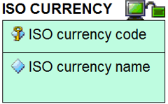

The third type is a relationship, or ‘foreign key constraint’. The lines between entities with the different symbols represent the different variants there are to these relationships. The relationships include ‘one to one’, ‘one to many’ and ‘many to many’. The exact relationship between the connected entities is described in words with a connecting phrase such as “qualifies the price of” or “is used by” or “contains allowed values for”. This connecting phrase will be contextual depending on the entities involved.
第三种类型是关系或“外键约束”，实体之间带有不同符号的线表示这些关系的不同变体。这些关系包括“一对一”、“一对多”和“多对多”。连接实体之间的确切关系是用带连接短语的词语描述的，如“限定……的价格”或“被……使用”或“包含……的容许值”。根据所涉及的实体，该连接短语将是语境相关的。
The variants of relationship differ from each other in other aspects:
关系的变体在其他方面彼此不同：
 | Variant one: The identifier of the first entity is passed as a non-identifying element of the other entity.  变体一：第一个实体的标识符作为另一个实体的非标识元素传递。
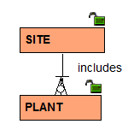 | Variant two: The identifier of the first entity is passed as an identifying element of the other entity. The line between the two entities is a solid line.  变体二：第一个实体的标识符作为其他实体的标识元素传递。两个实体之间的线是实线。
 | Variant three: Many-to-many relationships. These typically require an intermediate entity to clarify the constraints  变体三：多对多关系，通常需要一个中间实体以澄清约束。
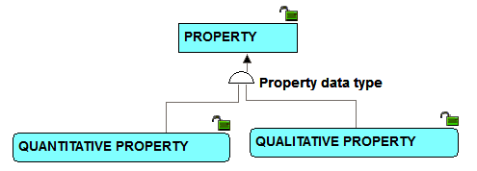 | Variant four: Subtyping – where multiple entities have the same identifier, but the subtypes need distinguishing from each other because they have different attributes.  变体四：子类型化——多个实体有相同标识符，但子类型因为属性不同需要彼此区分。
For further instructional material on how to read the CFIHOS Data Model, refer to the Data modelling Training Material [C-DM-901] on the CFIHOS SharePoint site.
如何解读CFIHOS数据模型的进一步指导资料见CFIHOS SharePoint网站上的数据建模培训资料[C-DM-901]。
For reference within the figures below, the following colour coding represents the source of the information:
以下颜色编码表示图1至图5中信息来源：
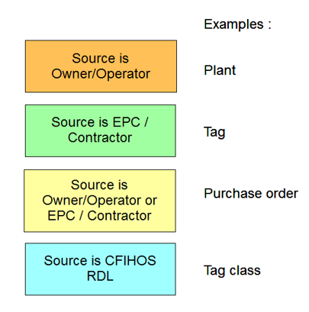
CFIHOS-SPTR-139
- High-level views of the CFIHOS data model CFIHOS数据模型高阶视图
This section provides examples from the CFIHOS data model. In order to understand the context of the entities that make up a capital facility and all the elements that are required in the handover of information, the following four extracts from the overall data model cover the key areas.
本条提供CFIHOS数据模型示例。为理解构成资产密集型设施的实体内容及信息移交要求的所有元素，从整体数据模型中提取的涵盖关键领域的四个摘录如下。
It is important to appreciate that even extracts of specialist areas of the model – e.g. the part covering documents and document metadata – is always a part of a bigger picture and the entities covered in one picture with the same name as those covered in another picture are, by definition, the same.
重要的是要认识到，即使是模型的各专门领域的摘录——例如涵盖文档和文档元数据的部分——也始终是更大的图的一部分。一张图涵盖实体与另一张图涵盖的有相同名称的实体根据定义是相同的。
CFIHOS-SPTR-140
Figure A.1
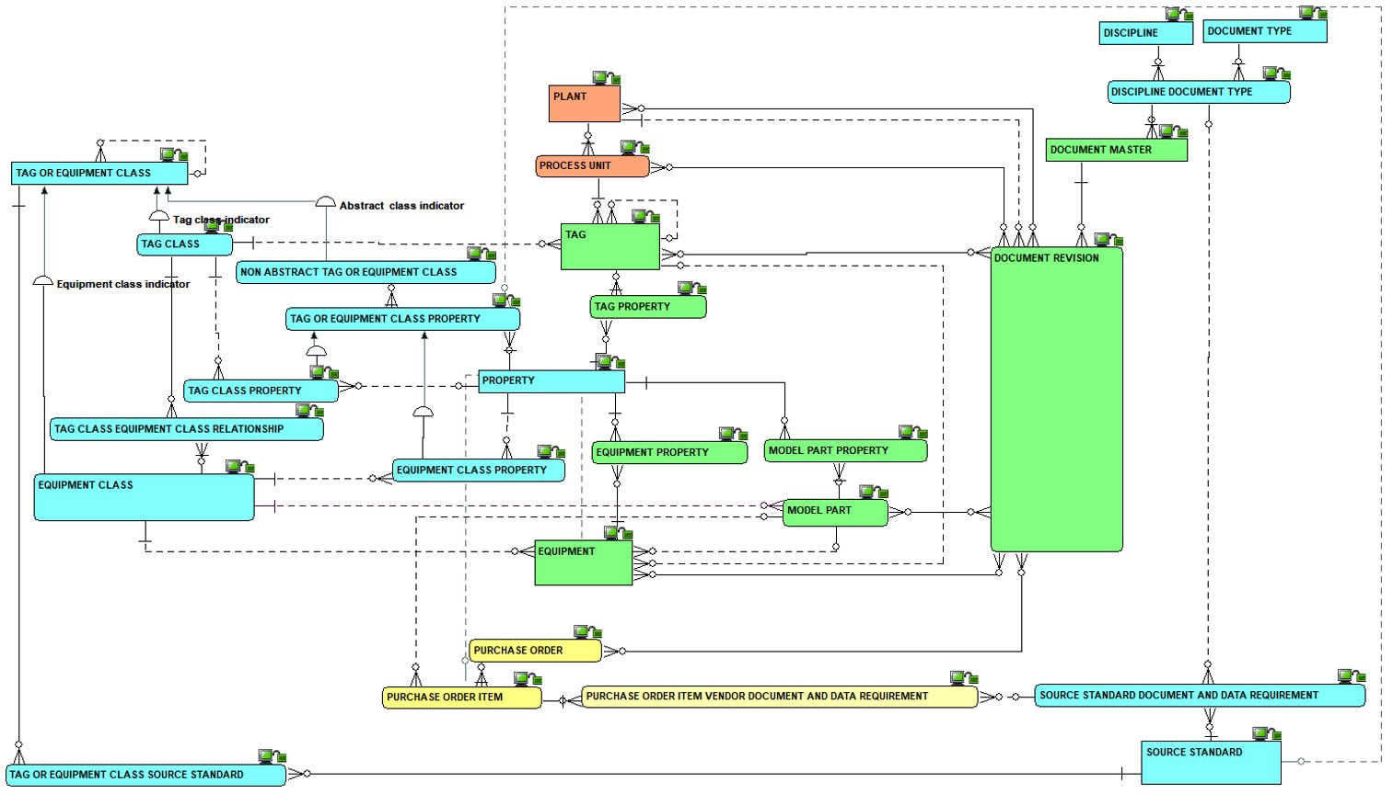
Figure A.1 - High-level overview of the complete model
图A.1 完整模型高阶概览
CFIHOS-SPTR-141
Figure A.2
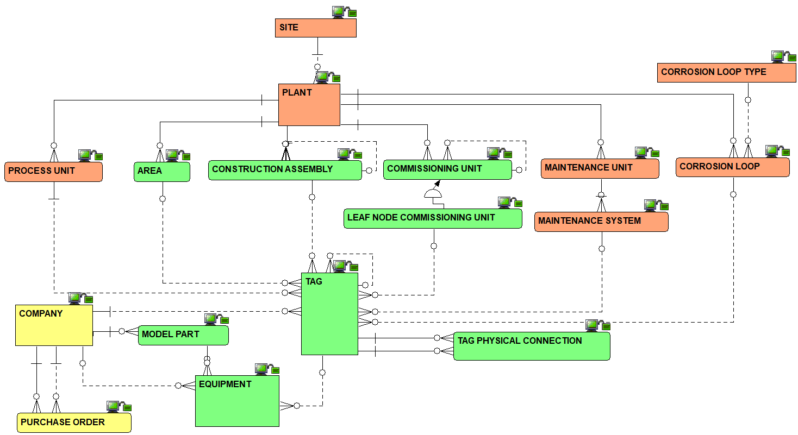
Figure A.2 - Overview of the Plant Breakdown Structure
图A.2 工厂分解结构概览
CFIHOS-SPTR-142
Figure A.3
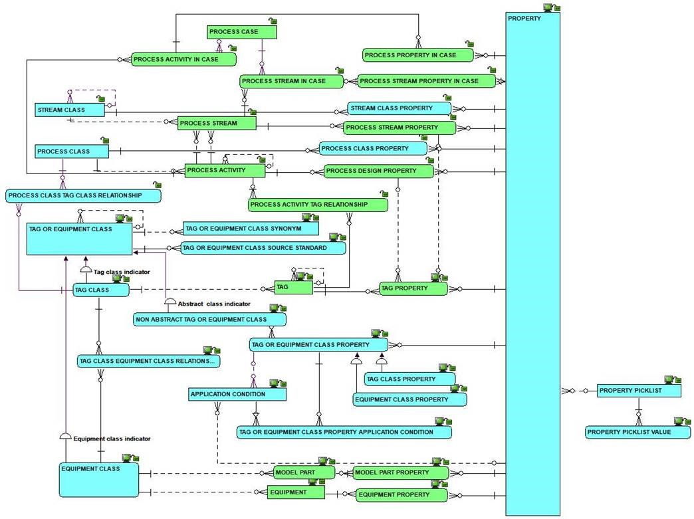
Figure A.3 - Overview of the Classifications and Properties including Processes, Streams and Cases
图A.3 分类和特性（包括工艺、流和工况）概览

CFIHOS-SPTR-143
Figure A.4
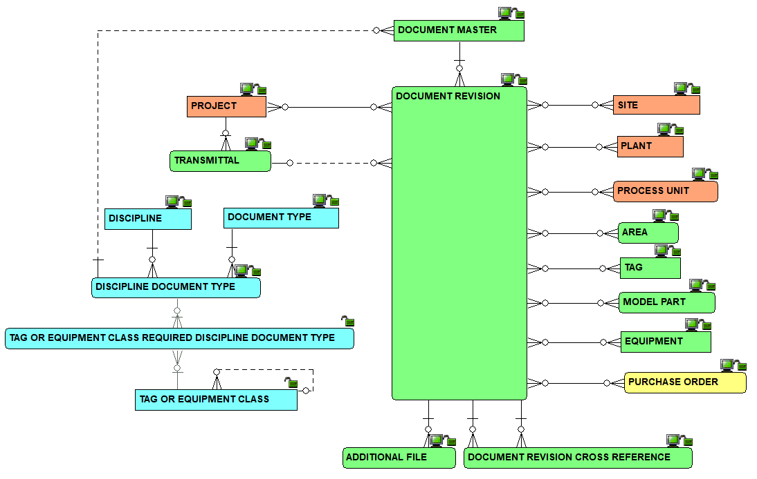
Figure A.4 - Overview of the document management metadata
图A.4 文档管理元数据概览

CFIHOS-SPTR-144
Figure A.5
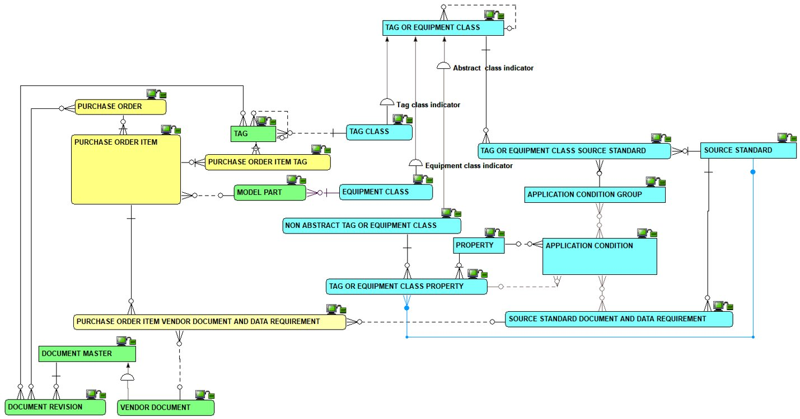
Figure A.5 – Overview of metadata requirements at time of procurement
图A.5 采购时元数据要求概览
CFIHOS-SPTR-145
- Complete set of views of the CFIHOS data model CFIHOS数据模型完整视图集
The complete data model is available in the following formats:
- As a PowerPoint slide
- In its native format.
完整数据模型采用以下格式提供：
- PowerPoint幻灯片
- 其源格式
Note: both versions come under the same document number [C-DM-001].
注：两个版本均使用同一文档编码[C-DM-001]。
- Data Dictionary 数据字典
CFIHOS-SPTR-146
- How to understand the data dictionary[C-DM-002] 如何理解数据字典[C-DM-002]
For each CFIHOS Entity Object the data dictionary provides the list of attributes, with their definitions, examples, formats, optionality, constraints and sources.
数据字典提供每个CFIHOS实体对象属性列表，及其定义、示例、格式、可选项、约束和来源。
Table A.1 describes the content of each column in the data dictionary.
表A.1描述数据字典每列内容。
CFIHOS-SPTR-147
Table A.1
Table A.1 - Data Dictionary Descriptions
表A.1 数据字典描述
Column  列 | Field Name  字段名 | Definition  定义
A | Section  条 | Provides a unique reference to each entity, with some mapping to the section used in the previous edition.  提供对每个实体的唯一引用，一部分映射至前一版本中使用的编号。
B | Object  对象 | Indicates whether the row represents and entity or attribute within the data model.  指明行是否代表数据模型中的实体或属性。
C | Entity Filter  实体过滤器 | Allows the user to group by entity to see all the information for that entity together.  允许用户按实体分组以一并查看该实体的所有信息。
D | Name  名称 | The name of the entity (in the physical world: table) or attribute (in the physical world: column)  实体名称（物理世界中：表）或属性的名称（物理世界中：列）。
E | Definition  定义 | What the entity or attribute is/means/represents  实体或属性是什么/意味什么/表示什么。
F | Note/ comment  注释/备注 | Supplementary information about the entity or attribute, though not part of the definition  关于实体或属性的补充信息，并非定义的一部分。
G | Example示例 | An example to assist in understanding  有助于理解的示例
H | Identifier/ Mandatory/ Optional  标识符/必填/选填 | An indication whether the attribute is (part of) what identifies one occurrence of the entity, or, if not (part of)- the identifier, whether the attribute is mandatory or optional  指明该属性是否（部分）标识实体的一次出现。或如果不是（部分）标识符，则该属性为必填或选填。
I | Format  格式 | An indication of attribute’s data type and its maximum size  指明属性数据类型及其最大大小。
J | Constraint  约束 | An indication of restrictions on allowable values of the attribute  指明对属性容许值的限制。
K | CFIHOS unique code  CFIHOS唯一标识码 | A code that, in CFIHOS, identifies uniquely an entity or an attribute.  CFIHOS中用于唯一标识实体或属性的编码。
L | Data source  数据源 | An indication of where the data is sourced from:  - Principal  - Contractor/supplier/manufacturer  - A mix of both  - Reference Data Library (RDL)  - RDL as a pick list  指明数据来源：  - 委托方  - 承包方/供应方/制造方  - 兼为委托方和承包方/供应方/制造方  - RDL（参考数据类库）  - RDL作为值列表
M | Former section (if different from last published version)  之前章节（如果与最新发布版本不同） | Indicates if the section code has changed since the last version. If it has the legacy value will be shown. If empty, there has been no change.  指明章节码自上一版本以来是否已更改。如果有更改，将显示上一版本值。如果为空，则表示没有更改。
N | Relationship verb  关系动词 | Provides a description of the relationship to the entity referenced in the Constraint column.  提供与约束列中引用的实体的关系的描述。

CFIHOS-SPTR-148
- CFIHOS Data Dictionary excerpt CFIHOS数据字典摘录
Excerpt of the CFIHOS Data Dictionary provided below for reference:
以下提供CFIHOS数据字典摘录供参考：

- Application Specific Data 应用程序特定数据
CFIHOS-SPTR-149
- Examples of Application Specific Data Deliverables 应用程序特定数据交付物示例
Table 3 identifies some typical application specific data deliverables. This is not an exhaustive list and is meant to include examples for reference.
表3识别一些典型应用程序特定数据交付物。此非详尽列表，而为列出示例，以供参考。
CFIHOS-SPTR-150
Table A.2
Table A.2 - Application Specific Database Examples
表A.2 应用程序特定数据库示例
Application Specific Database Description  应用程序特定数据库描述 | Application name and version  (intentionally left blank)  应用程序名称和版本  （故意留空） | Handover Status  移交状态
Development of the process simulation model or multi-purpose dynamic simulator (MPDS) and related deliverables, used for process plant design, production optimization, engineering modifications, operator training simulator.  准备用于流程工厂设计、生产优化、工程修改、操作员培训仿真机的工艺模拟模型或MPDS（多用途动态仿真机）和相关交付物。 |  | As Built  竣工状态
Development of the 2D Intelligent P&ID design application, used to generate ‘intelligent’ P&IDs, line list and related deliverables.  用于生成“智能”P&ID、管线表和相关交付物的2D智能P&ID设计应用程序。 |  | As Built  竣工状态
Development of the 2D instrumentation design application data, used to generate loop diagrams, electrical signal I/O lists, instrument index, instrument specification sheets and input to the configuration of the plant automation systems..  准备用于生成回路图、电气信号I/O清册、仪表清册、仪表规格表和工厂自动化系统配置输入到的2D仪表设计应用程序数据。 |  | As Built  竣工状态
Development of the 2D electrical design application, used to design distribution, single line drawings, specification Sheets, termination drawings and as input to electrical load simulations.  准备用于设计配电、单线图、规格表、端子图和作为电气负荷模拟输入的2D电气设计应用程序。 |  | As Built  竣工状态
Development of the multi-discipline 3D Model design application, to facilitate clash free design, produce 2D drawings from the 3D master, generate MTO, facilitate construction management and operator training and development of digital twins.  准备多专业3D模型设计应用程序，以备无碰撞设计、从3D母体生成2D工程图、生成MTO（材料表）、施工管理、操作员培训和数字孪生开发。 |  | As-built  竣工状态
3D Structural or Pipe stress analysis models.  3D结构或管道应力分析模型。 |  | As Design  设计状态
Editable backups of Plant Automation Systems and other configurations related the plant control, such as alarm management systems and Safety Instrumented Functions tools.  工厂自动化系统和其他与工厂控制相关的配置的可编辑备份，如报警管理系统和SIF（安全仪表系统）工具。 |  | As Built  竣工状态
Blast analysis model, Gas dispersion studies, risk analysis model for use in safety studies, Safety Case amendments.  用于安全研究、安全档案修正的爆炸分析模型、气体扩散研究、风险分析模型。 |  | As Design  设计状态
Geospatial Information System database for Pipelines and/or Subsea assets.  用于管线和/或海底资产的GIS（地理信息系统）数据库。 |  | As Design  设计状态
Spare Parts Database for definitions of Bills of Material, selection and procurement of spare parts.  用于定义BOM（物料清单）、选择和采购备件的备件数据库。 |  | As Built  竣工状态
Computerized Maintenance Management System Database, for the definition and management of Maintenance Plans and Maintenance Job Routines.  用于定义和管理MP（维修计划）及MJR（维修作业程序）的CMMS（计算机化维修管理系统）数据库。 |  | As Built  竣工状态
Reliability Centered Maintenance Database, for optimization of maintenance strategies  用于优化维修策略的RCM（以可靠性为中心的维修）数据库。 |  | As Built  竣工状态
Predictive and/or prescriptive maintenance management system application |  | As Built  竣工状态
Pressurized Equipment Integrity Management Database, For definition and management of inspection plans, and monitoring of corrosion rates  用于定义和管理检验计划以及监测腐蚀率的PEIM（压力设备完整性管理）数据库。 |  | As Built  竣工状态
Risk Based Inspection Database for optimization of inspection strategies  用于优化检验策略的RBI（基于风险的检验）数据库。 |  | As Built  竣工状态

Bibliography 参考文献
CFIHOS-BIB-1

EPISTLE Process Industry Data Handover Guide Part 1 and Part 2
EPISTLE（欧洲流程工业STEP（产品模型数据交换标准）技术联络执行委员会）流程工业数据移交指南 第1部分和第2部分

CFIHOS-BIB-2

NIST Capital Facilities Information Handover Guide, Part 1
NIST（美国国家标准技术研究院）资产密集型设施信息移交指南 第1部分

CFIHOS-BIB-3

Shell EIS Hand Over Specification
壳牌 EIS（工程信息规范）移交规范

CFIHOS-BIB-4

CEN ORCHID Roadmap Standardising Information Across the Plant Engineering Supply Chain - Part 1: Direction and Framework
CEN（欧洲标准化委员会） ORCHID（工业数据统筹）工厂工程供应链信息标准化路线图 第1部分：方向与框架

CFIHOS-BIB-5

PISTEP Process Plant Engineering Activity Model
PISTEP（流程工业产品模型数据交换标准） 流程工厂工程活动模型

CFIHOS-BIB-6

3002007425 Rev 1,
EPRI New Nuclear Power Plant Information Handover Guide, March 2016, R. King
EPRI（美国电力研究院）新核电站信息移交指南，2016年3月，R. King

